Project Report

1. INTRODUCTION
   1. Project Overview
   2. Purpose
2. LITERATURE SURVEY
   1. Existing problem
   2. References
   3. Problem Statement Definition
3. IDEATION & PROPOSED SOLUTION
   1. Empathy Map Canvas
   2. Ideation & Brainstorming
   3. Proposed Solution
   4. Problem Solution fit
4. REQUIREMENT ANALYSIS
   1. Functional requirement
   2. Non-Functional requirements
5. PROJECT DESIGN
   1. Data Flow Diagrams
   2. Solution & Technical Architecture
   3. User Stories
6. PROJECT PLANNING & SCHEDULING
   1. Sprint Planning & Estimation
   2. Sprint Delivery Schedule
   3. Reports from JIRA
7. CODING & SOLUTIONING (Explain the features added in the project along with code)
   1. Feature 1
   2. Feature 2
   3. Database Schema (if Applicable)
8. TESTING
   1. Test Cases
   2. User Acceptance Testing
9. RESULTS
   1. Performance Metrics
10. ADVANTAGES & DISADVANTAGES
11. CONCLUSION
12. FUTURE SCOPE
13. APPENDIX

Source Code

GitHub Link

# INTRODUCTION

1. INTRODUCTION

* 1. PROJECT OVERVIEW

SMART SOLUTIONS FOR RAILWAYS is to manage Indian Railways is the largest railway network in Asia and additionally world's second largest network operated underneath a single management. Due to its large size it is difficult to monitor the cracks in tracks manually. This paper deals with this problem and detects cracks in tracks with the help of ultrasonic sensor attached to moving assembly with help of stepper motor. Ultrasonic sensor allows the device to moves back and forth across the track and if there is any fault, it gives information to the cloud server through which railway department is informed on time about cracks and many lives can be saved. This is the application of IoT, due to this it is cost effective system. This effective methodology of continuous observation and assessment of rail tracks might facilitate to stop accidents. This methodology endlessly monitors the rail stress, evaluate the results and provide the rail break alerts such as potential buckling conditions, bending of rails and wheel impact load detection to the concerned authorities.

* 1. PURPOSE

Internet is basically system of interconnected computers through network. But now its use is changing with changing world and it is not just confined to emails or web browsing. Today’s internet also deals with embedded sensors and has led to development of smart homes, smart rural area, e-health care’s etc. and this introduced the concept of IoT . Internet of Things refers to interconnection or communication between two or more devices without humanto-human and human-to-computer interaction. Connected devices are equipped with sensors or actuators perceive their surroundings. IOT has four major components which include sensing the device, accessing the device, processing the information of the device, and provides application and services. In addition to this it also provides security and privacy of data . Automation has affected every aspect of our daily lives. More improvements are being introduced in almost all fields to reduce human effort and save time. Thinking of the same is trying to introduce automation in the field of track testing. Railroad track is an integral part of any company's asset base, since it provides them with the necessary business functionality. Problems that occur due to problems in railroads need to be overcome. The latest method used by the Indian railroad is the tracking of the train track which requires a lot of manpower and is time-consuming

# LITERATURE SURVEY

2. LITERATURE SURVEY

## 2.1 EXISTING SYSTEM

In the Existing train tracks are manually researched. LED (Light Emitting Diode) and LDR (Light Dependent Resister) sensors cannot be implemented on the block of the tracks ]. The input image processing is a clamorous system with high cost and does not give the exact result. The Automated Visual Test Method is a complicated method as the video color inspection is implemented to examine the cracks in rail track which does not give accurate result in bad weather. This traditional system delays transfer of information. Srivastava et al., (2017) proposed a moving gadget to detect the cracks with the help of an array of IR sensors to identify the actual position of the cracks as well as notify to nearest railway station . Mishra et al., (2019) developed a system to track the cracks with the help of Arduino mega power using solar energy and laser. A GSM along with a GPS module was implemented to get the actual location of the faulty tracks to inform the authorities using SMS via a link to find actual location on Google Maps. Rizvi Aliza Raza presented a prototype in that is capable of capturing photos of the track and compare it with the old database and sends a message to the authorities regarding the crack detected. The detailed analysis of traditional railway track fault detection techniques is explained in table

## 2.2 REFERENCES

1. D. Hesse, “Rail Inspection Using Ultrasonic Surface Waves” Thesis, Imperial College of London, 2007.
2. Md. Reya Shad Azim1 , Khizir Mahmud2 and C. K. Das. Automatic railway

track switching system, International Journal of Advanced Technology, Volume 54, 2014.

1. S. Somalraju, V. Murali, G. saha and V. Vaidehi, “Title-robust railway crack detection scheme using LED (Light Emitting Diode) - LDR (Light Dependent Resistor) assembly IEEE 2012.
2. S. Srivastava, R. P. Chourasia, P. Sharma, S. I. Abbas, N. K. Singh, “Railway Track Crack detection vehicle”, IARJSET, Vol. 4, pp. 145-148, Issued in 2, Feb 2017.
3. U. Mishra, V. Gupta, S. M. Ahzam and S. M. Tripathi, “Google Map Based

Railway Track Fault Detection Over the Internet”, International Journal of Applied Engineering Research, Vol. 14, pp. 20-23, Number 2, 2019.

1. R. A. Raza, K. P. Rauf, A. Shafeeq, “Crack detection in Railway track using Image processing”, IJARIIT, Vol. 3, pp. 489-496, Issue 4, 2017.
2. N. Bhargav, A. Gupta, M. Khirwar, S. Yadav, and V. Sahu, “Automatic Fault

Detection of Railway Track System Based on PLC (ADOR TAST)”, International

Journal of Recent Research Aspects, Vol. 3, pp. 91-94, 2016

## 2.3 PROBLEM STATEMENT DEFINITION

Among the various modes of transport, railways is one of the biggest modes of transport in the world. Though there are competitive threats from airlines, luxury buses, public transports, and personalized transports the problem statement is to answer the question “What are the problems faced by the passengers while travelling by train at station and on board”

# 

# IDEATION AND PROPOSED SOLUTION

3. IDEATION AND PROPOSED SOLUTON

## 3.1 EMPATHY MAP CANVAS

## 3.2 IDEATION & BRAINSTORMING

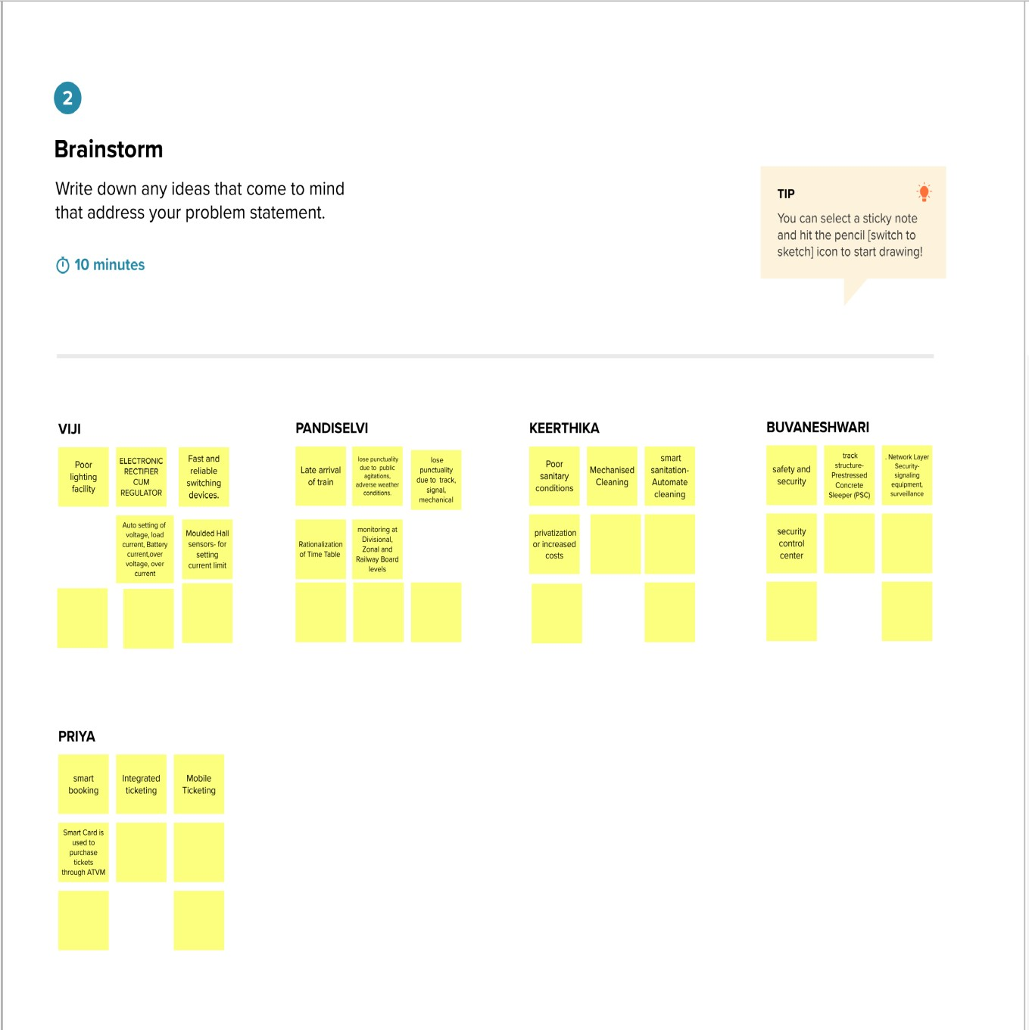

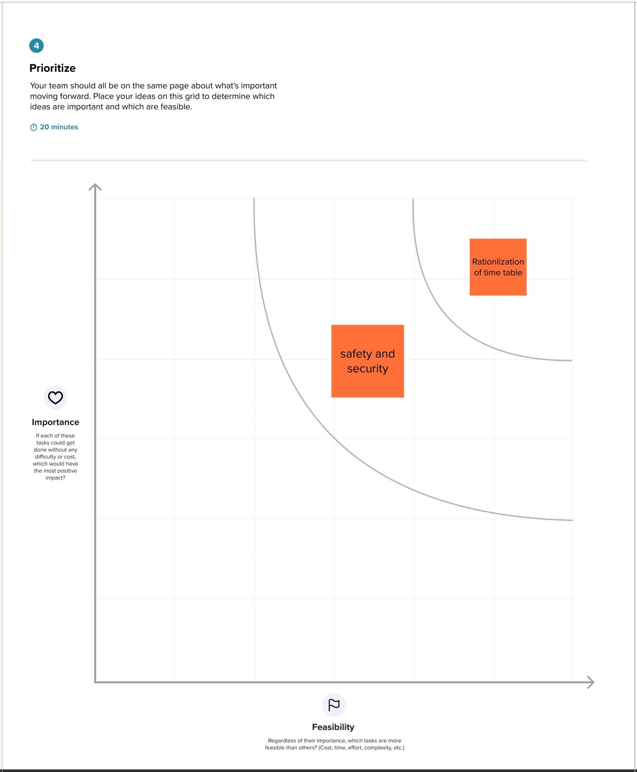

## 3.3 PROPOSED SOLUTION

|  |  |  |  |  |  |  |
| --- | --- | --- | --- | --- | --- | --- |
| S. N0 | | | Parameter | | Description | |
| 1. | | | Problem Statement (Problem to be solved) | | To maintain the tracks, repairs and services to avoid accident, safeguard of things, track the running status of the train in smart railway system and reach the destination place on time due to train delay. | |
| 2. | | | Idea / Solution description | | The idea is able to predict the delays in prior and helps to decide best alternatives to reduce delays. With the help of sensor to detect the crack in rail track with measuring the distance from the track to sensor to reduce the accidents. | |
| 3. | | | Novelty / Uniqueness | | Improving and increasing customer experience, vehicle tracking system.IOT is used along with AI which Provides enhanced features in finding out delays. | |
| 4. | | | Social Impact / Customer Satisfaction | | Predicting delay and detecting the train arrival time so that help the passenger to act accordingly and keep tracking the location of the train and travel in easy and modern way | |
| 5. | | | Business Model (Revenue Model) | | Product and service sales to the railways system .User booking and Scheduling Service it makes passengers to avoid delays which will make more number of people to shift to railway mode of transportation which increases the revenue of railways | |
| 6. |  | Scalability of the Solution | | | | Using IoT in railways, increased the use of trains among people due to its convenient usage.So it will automatically increase the both revenue and expenses ,but the revenue will chase the expenses and will be boosting . |
|  | | |

## 3.4 PROBLEM SOLUTION FIT

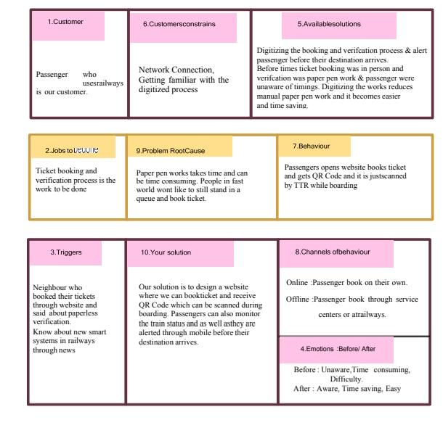

# REQUIREMENT ANALYSIS

4. REQUIREMENT ANALYSIS

## 4.1. FUNCTIONAL REQUIREMENTS

|  |  |  |
| --- | --- | --- |
| FR No. | Functional Requirement  (Epic) | Sub Requirement (Story / Sub-Task) |
| FR-1 | Passenger ticket booking | Booking through the online railway mobile app and website. |
| FR-2 | Booking Confirmation | Booking Confirmation via Email Booking Confirmation via SMS |
| FR-3 | Passenger objections and feedback | Through the online application, SMS, and email to the respective authority. |
| FR-4 | Passenger schedule | Passenger can see their train timing through the mobile app |
| FR-5 | Passenger Emergency | Passengers in an Emergency, in case of accidents, natural disasters, or theft during the journey can complain through online applications, emergency calls, SMS, and email. |

4.2. NON-FUNCTIONAL REQUIREMENTS

|  |  |  |
| --- | --- | --- |
| FR No. | Non-Functional Requirement | Description |
| NFR-1 | Usability | Within periodic maintenance, we can detect cracks in the railway track. which will be highly usable on remote railway tracks. |
| NFR-2 | Security | Accidents and property damage can be prevented with the help of our smart sensors which immediately send the fault to the pilot and administration. |
| NFR-3 | Reliability | Traffic lights and signalling can be made accurately with the help of sensors. so it is more reliable. |
| NFR-4 | Performance | Communication plays a vital role in transferring the crack-detected signal to the responsible authority so that they can take appropriate measures within a short span. |
| NFR-5 | Availability | Our idea is to make the crack alert to all the trains passing through that faultprone area. |
| NFR-6 | Scalability | Our project is based on IoT & cloud, which makes the pilot and authority updated every single sec.  Adhoc is easy to handle. |

# PROJECT DESIGN

## 5. PROJECT DESIGN

5.1 DATA FLOW DIAGRAMS

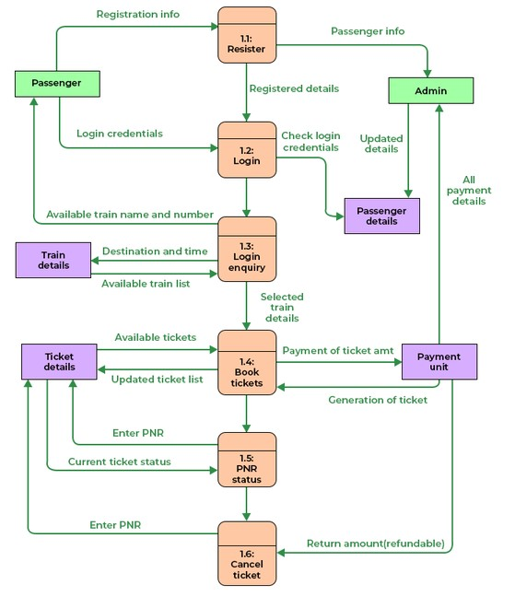

5.2 SOLUTION & TECHNICAL ARCHITECTURE

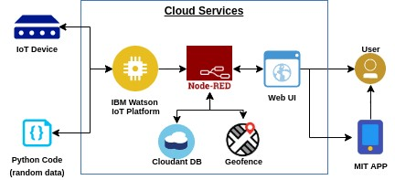

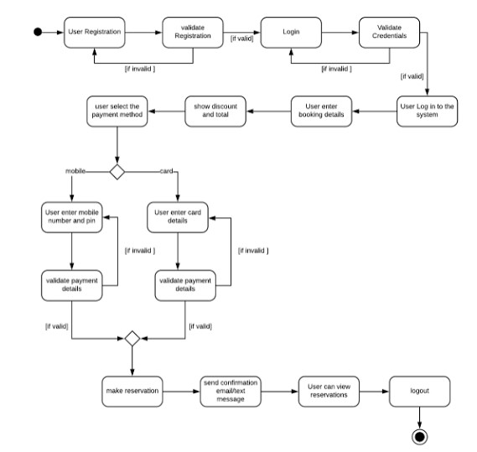

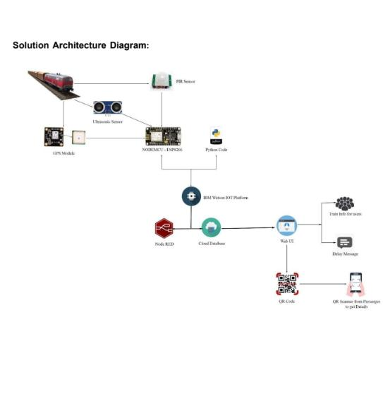

5.3 USER STORIES

|  |  |  |  |  |  |  |
| --- | --- | --- | --- | --- | --- | --- |
| User Type | Functional  Requirement (Epic) | User  Story  Number | User Story / Task | Acceptance criteria | Priority | Release |
| Customer    (Mobile user, Web user) | Registration | USN-1 | As a user, I can register through the form by  Filling in my details | I can register and create my account / dashboard | High | Sprint-1 |
|  |  | USN-2 | As a user, I can register through phone  numbers, Gmail,  Facebook or other social sites | I can register & create my  dashboard with  Facebook login or other social sites | High | Sprint-2 |
|  | Conformation | USN-3 | As a user, I will receive confirmation through  email or OTP once registration is successful | I can receive confirmation email & click confirm. | High | Sprint-1 |
|  | Authentication/Login | USN-4 | As a user, I can login via login id and  password or through  OTP received on register phone number | I can login and access my  account/dashboard | High | Sprint-1 |
|  | Display Train details | USN-5 | As a user, I can enter the start and destination  to get the list of trains  available connecting the above | I can view the train details  (name & number), corresponding  routes it passes  through based on the start and destination entered. | High | Sprint-1 |
|  | Booking | USN-6 | As a use, I can provide the basic details such  as a name, age, gender  etc… | I will view, modify or confirm the details enter. | High | Sprint-1 |
|  |  | USN-7 | As a user, I can choose the class, seat/berth.  If a preferred seat/berth isn’t available I can be  allocated based on the availability. | I will view, modify or confirm the  seat/class berth selected | High | Sprint-1 |
|  | Payment | USN-8 | As a user, I can choose to pay through credit Card/debit card/UPI. | I can view the payment  Options available and select my  desirable choice  To proceed with the payment | High | Sprint-1 |
|  |  | USN-9 | As a user, I will be redirected to the selected  Payment gateway and upon successful | I can pay through the payment portal  and confirm the booking if any changes need to | High | Sprint-1 |
| User Type | Functional  Requirement (Epic) | User  Story  Number | User Story / Task | Acceptance criteria | Priority | Release |
|  |  |  | completion of payment I’ll be redirected to the booking website. | be done  I can move back to the initial payment page |  |  |
|  | Ticket generation | USN-10 | As a user, I can download the  generated  e-ticket for my journey  along with the QR code which is used for  authentication during my journey. | I can show the generated QR code so that  authentication can be done quickly. | High | Sprint-1 |
|  | Ticket status | USN-11 | As a user, I can see the status of my ticket  Whether it’s confirmed/waiting/RAC. | I can confidentially get the  Information and arrange alternate  transport if the ticket isn’t  Confirmed | High | Sprint-1 |
|  | Remainders notification | USN-12 | As a user, I get remainders about my journey  A day before my actual journey. | I can make sure that I don’t miss the  journey because of the constant notifications. | Medium | Sprint-2 |
|  |  | USN-13 | As a user, I can track the train using GPS and can get information such as ETA,  Current stop and delay. | I can track the train and get to know  about the delays pian accordingly | Medium | Sprint-2 |
|  | Ticket cancellation | USN-14 | As a user, I can cancel my tickets if there’s any Change of plan | I can cancel the ticket and get a  refund based on  how close the date is to the journey. | High | Sprint-1 |
|  | Raise queries | USN-15 | As a user, I can raise queries through the query box or via mail. | I can view my pervious queries. | Low | Sprint-2 |
| Customer care  Executive | Answer the queries | USN-16 | As a user, I will answer the questions/doubts  Raised by the customers. | I can view the queries and make it once resolved | Medium | Sprint-2 |
| Administrator | Feed details | USN-17 | As a user, I will feed information about the  trains delays and add extra seats if a new compartment is added. | I can view and ensure the  corrections of the information fed. | High | Sprint-1 |

# PROJECT PLANNING AND SCHEDULING

6. PROJECT PLANNING AND SCHEDULING

## 6.1. SPRINT PLANNING& ESTIMATION

|  |  |  |  |  |  |  |
| --- | --- | --- | --- | --- | --- | --- |
| Sprint | Functional  Requirement  (Epic) | User Story Number | User Story / Task | Story Points | Priority | Team  Members |
| Sprint-1 | Registration | USN-1 | As a user, I can register through the form by  Filling in my details | 2 | High | Shri |
| Sprint-1 |  | USN-2 | As a user, I can register through phone  numbers, Gmail, Facebook or other social sites | 1 | High | Subbu |
| Sprint-1 | Conformation | USN-3 | As a user, I will receive confirmation through  email or OTP once registration is successful | 2 | Low | Maha |
| Sprint-1 | login | USN-4 | As a user, I can login via login id and password or through OTP received on register phone number | 2 | Medium | Melba |
| Sprint-1 | Display Train details | USN-5 | As a user, I can enter the start and destination to get the list of trains  available connecting the above | 1 | High | Shri |
| Sprint-2 | Booking | USN-6 | As a use, I can provide the basic details such as  a name, age, gender etc… | 2 | High | Shri |
| Sprint-2 |  | USN-7 | As a user, I can choose the class, seat/berth. If a preferred seat/berth isn’t available I can be  allocated based on the availability | 1 | Low | Subbu |
| Sprint-2 | Payment | USN-8 | As a user, I can choose to pay through credit  Card/debit card/UPI. | 1 | High | Maha |
| Sprint | Functional  Requirement (Epic) | User Story  Number | User Story / Task | Story Points | Priority | Team  Members |
| Sprint-2 |  | USN-9 | As a user, I will be redirected to the selected | 2 | High | Shri |
| Sprint-3 | Ticket generation | USN-10 | As a user, I can download the generated e- ticket for my journey along with the QR code which is used for authentication during my journey. | 1 | High | Maha |
| Sprint-3 | Ticket status | USN-11 | As a user, I can see the status of my ticket | 2 | High | Subbu |
|  |  |  | Whether it’s confirmed/waiting/RAC. |  |  |  |
| Sprint-3 | Remainders notification | USN-12 | As a user, I get remainders about my journey A day before my actual journey. | 1 | High | Melba |
| Sprint-3 | Ticket cancellation | USN-13 | As a user, I can track the train using  GPS and can get information such as  ETA, Current stop and delay | 2 | High | Shri |
| Sprint-4 |  | USN-14 | As a user, I can cancel my tickets if there’s any Change of plan | 1 | High | Subbu |
| Sprint-4 | Raise queries | USN-15 | As a user, I can raise queries through the query box or via mail. | 2 | Medium | Maha |
| Sprint-4 | Answer the queries | USN-16 | As a user, I will answer the questions/doubts  Raised by the customers. | 2 | High | Melba |
| Sprint-4 | Feed details | USN-17 | As a user, I will feed information about the trains delays and add extra seats if a new compartment is added. | 1 | High | Subbu |

## 

## 6.2. SPRINT DELIVERY SCHEDULE

|  |  |  |  |  |  |  |
| --- | --- | --- | --- | --- | --- | --- |
| Sprint | Total  Story  Points | Duration | Sprint Start Date | Sprint End  Date  (Planned) | Story Points Completed (as on Planned End Date) | Sprint Release Date (Actual) |
| Sprint-1 | 20 | 6 Days | 24 Oct 2022 | 29 Oct 2022 | 20 | 29 Oct 2022 |
| Sprint-2 | 20 | 6 Days | 31 Oct 2022 | 05 Nov 2022 | 20 | 5 Nov 2022 |
| Sprint | Total Story Points | Duration | Sprint Start Date | Sprint End Date (Planned) | Story Points  Completed (as on  Planned End  Date) | Sprint Release Date (Actual) |
| Sprint-3 | 20 | 6 Days | 07 Nov 2022 | 12 Nov 2022 | 20 | 12 Nov 2022 |
| Sprint-4 | 20 | 6 Days | 14 Nov 2022 | 19 Nov 2022 | 20 | 19 Nov2022 |

## 

6.3. REPORTS FROM JIRA

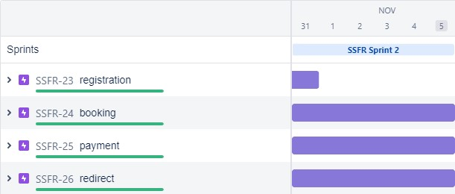

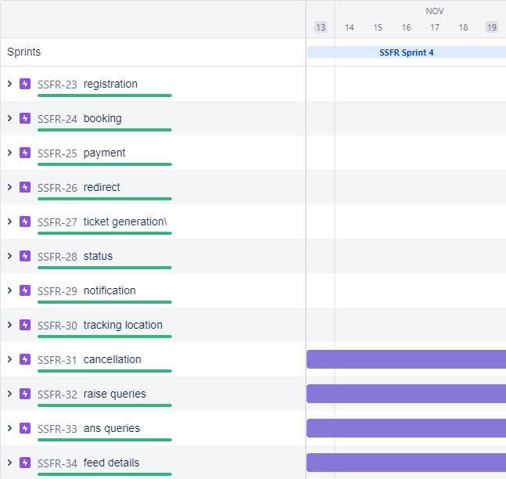

# CODING AND SOLUTIONING

7. CODING AND SOLUTIONING

## 7.1. FEATURE 1 o

* IOT device
* IBM Watson platform
* Node red
* Cloudant DB
* Web UI
* Geofence • MIT App
* Python code

## 7.2. FEATURE 2

* Registration
* Login
* Verification
* Ticket Booking
* Payment
* Ticket Cancellation
* Adding Queries

labl_0 = Label(base, text="Registration form",width=20,font=("bold",

20))

labl_0.place(x=90,y=53)

lb1= Label(base, text="Enter Name", width=10, font=("arial",12)) lb1.place(x=20, y=120) en1= Entry(base)

en1.place(x=200, y=120)

lb3= Label(base, text="Enter Email", width=10, font=("arial",12)) lb3.place(x=19, y=160) en3= Entry(base)

en3.place(x=200, y=160)

lb4= Label(base, text="Contact Number", width=13,font=("arial",12)) lb4.place(x=19, y=200) en4= Entry(base)

en4.place(x=200, y=200)

lb5= Label(base, text="Select Gender", width=15, font=("arial",12)) lb5.place(x=5, y=240)

var = IntVar()

Radiobutton(base, text="Male", padx=5,variable=var, value=1).place(x=180, y=240)

Radiobutton(base, text="Female", padx =10,variable=var, value=2).place(x=240,y=240)

Radiobutton(base, text="others", padx=15, variable=var, value=3).place(x=310,y=240)

list_of_cntry = ("United States", "India", "Nepal", "Germany") cv = StringVar() drplist= OptionMenu(base, cv, *list_of_cntry) drplist.config(width=15) cv.set("United States") lb2= Label(base, text="Select Country", width=13,font=("arial",12)) lb2.place(x=14,y=280)

drplist.place(x=200, y=275)

lb6= Label(base, text="Enter Password", width=13,font=("arial",12)) lb6.place(x=19, y=320) en6= Entry(base, show='*')

en6.place(x=200, y=320)

lb7= Label(base, text="Re-Enter Password",

width=15,font=("arial",12)) lb7.place(x=21, y=360) en7 =Entry(base, show='*')

en7.place(x=200, y=360)

Button(base, text="Register", width=10).place(x=200,y=400) base.mainloop()

def generateOTP() :

# Declare a digits variable # which stores all digits digits = "0123456789"

OTP = ""

# length of password can be changed # by changing value in range for i in range(4) :

OTP += digits[math.floor(random.random() * 10)]

return OTP

# Driver code if __name__ == "__main__" :

print("OTP of 4 digits:", generateOTP())

digits="0123456789" OTP=""

for i in range(6):

OTP+=digits[math.floor(random.random()*10)] otp = OTP + " is your OTP" msg= otp s = smtplib.SMTP('smtp.gmail.com', 587)

s.starttls()

s.login("Your Gmail Account", "You app password") emailid = input("Enter your email: ")

s.sendmail('&&&&&&&&&&&',emailid,msg) a = input("Enter Your OTP >>: ") if a == OTP:

print("Verified") else:

print("Please Check your OTP again") roo

# TESTING

## 8. TESTING

8.1.TEST CASES

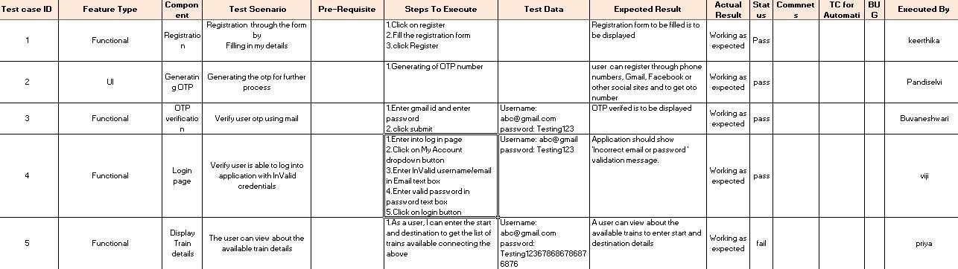

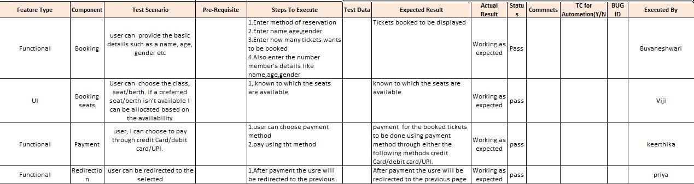

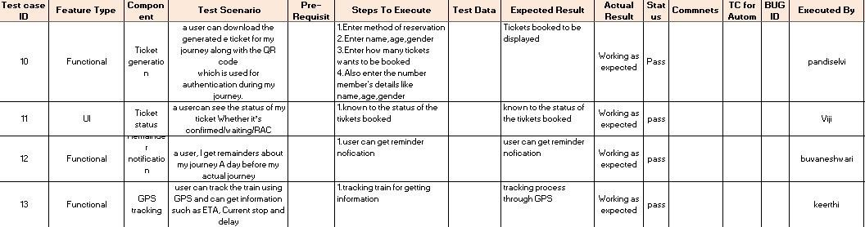

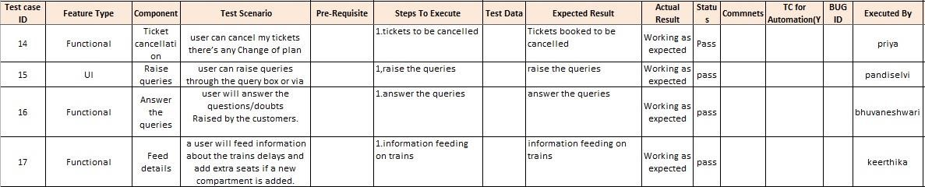

# RESULTS

9. RESULTS

## 9.1. PERFORMANCE METRICS

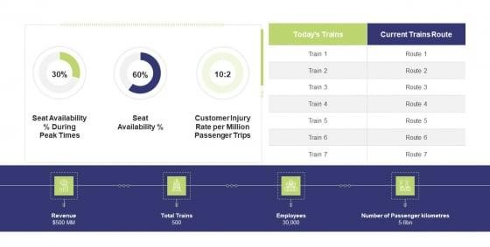

# ADVANTAGES & DISADVANTAGES

10.ADVANTAGES & DISADVANTAGES

## 10.1. ADVANTAGES

* Openness – compatibility between different system modules, potentially from different vendors;
* Orchestration – ability to manage large numbers of devices, with full visibility over them; o Dynamic scaling – ability to scale the system according to the application needs, through resource virtualization and cloud operation;
* Automation – ability to automate parts of the system monitoring application, leading to better performance and lower operation costs.

## 10.2. DISADVANTAGES

* Approaches to flexible, effective, efficient, and low-cost data collection for both railway vehicles and infrastructure monitoring, using regular trains;

* Data processing, reduction, and analysis in local controllers, and subsequent sending of that data to the cloud, for further processing;

* Online data processing systems, for real-time monitoring, using emerging communication technologies;

* Integrated, interoperable, and scalable solutions for railway systems preventive maintenance.

# CONCLUSION

11.CONCLUSION

Accidents occurring in Railway transportation system cost a large number of lives. So this system helps us to prevent accidents and giving information about faults or cracks in advance to railway authorities. So that they can fix them and accidents cases becomes less. This project is cost effective. By using more techniques they can be modified and developed according to their applications. By this system many lives can be saved by avoiding accidents. The idea can be implemented in large scale in the long run to facilitate better safety standards for rail tracks and provide effective testing infrastructure for achieving better results in the future.

# FUTURE SCOPE

12.FUTURE SCOPE

In future CCTV systems with IP based camera can be used for monitoring the visual videos captured from the track. It will also increase security for both passengers and railways. GPS can also be used to detect exact location of track fault area, IP cameras can also be used to show fault with the help of video. Locations on Google maps with the help of sensors can be used to detect in which area track is broken

# APPENDIX

13.APPENDIX

## 13.1. SOURCE PROGRAM

import math, random

import os import smtplib import sqlite3 import requests

from bs4 import BeautifulSoup

from django.contrib.auth.base_user import AbstractBaseUser from django.db import models

import logging import pandas as pd import pyttsx3

from plyer import notification

import time import numpy as np import matplotlib.pyplot as plt from PIL import Image, ImageDraw from pickle import load,dump

import smtplib, ssl

from email.mime.text import MIMEText from email.mime.multipart import MIMEMultipart import email

from email import encoders

from email.mime.base import MIMEBase

import attr

from flask import Blueprint, flash, redirect, request, url_for from flask.views import MethodView from flask_babelplus import gettext as _

from flask_login import current_user, login_required

from pluggy import HookimplMarker

from tkinter import*

base = Tk() base.geometry("500x500")

base.title("registration form")

labl_0 = Label(base, text="Registration form",width=20,font=("bold",

20))

labl_0.place(x=90,y=53)

lb1= Label(base, text="Enter Name", width=10, font=("arial",12)) lb1.place(x=20, y=120) en1= Entry(base)

en1.place(x=200, y=120)

lb3= Label(base, text="Enter Email", width=10, font=("arial",12)) lb3.place(x=19, y=160) en3= Entry(base)

en3.place(x=200, y=160)

lb4= Label(base, text="Contact Number", width=13,font=("arial",12)) lb4.place(x=19, y=200) en4= Entry(base)

en4.place(x=200, y=200)

lb5= Label(base, text="Select Gender", width=15, font=("arial",12)) lb5.place(x=5, y=240) var = IntVar()

Radiobutton(base, text="Male", padx=5,variable=var,

value=1).place(x=180, y=240)

Radiobutton(base, text="Female", padx =10,variable=var, value=2).place(x=240,y=240)

Radiobutton(base, text="others", padx=15, variable=var, value=3).place(x=310,y=240)

list_of_cntry = ("United States", "India", "Nepal", "Germany") cv = StringVar() drplist= OptionMenu(base, cv, *list_of_cntry) drplist.config(width=15) cv.set("United States") lb2= Label(base, text="Select Country", width=13,font=("arial",12)) lb2.place(x=14,y=280)

drplist.place(x=200, y=275)

lb6= Label(base, text="Enter Password", width=13,font=("arial",12)) lb6.place(x=19, y=320) en6= Entry(base, show='*')

en6.place(x=200, y=320)

lb7= Label(base, text="Re-Enter Password",

width=15,font=("arial",12)) lb7.place(x=21, y=360) en7 =Entry(base, show='*')

en7.place(x=200, y=360)

Button(base, text="Register", width=10).place(x=200,y=400) base.mainloop()

def generateOTP() :

# Declare a digits variable # which stores all digits digits = "0123456789"

OTP = ""

# length of password can be changed # by changing value in range for i in range(4) :

OTP += digits[math.floor(random.random() * 10)]

return OTP

# Driver code if __name__ == "__main__" :

print("OTP of 4 digits:", generateOTP())

digits="0123456789" OTP=""

for i in range(6):

OTP+=digits[math.floor(random.random()*10)] otp = OTP + " is your OTP" msg= otp s = smtplib.SMTP('smtp.gmail.com', 587)

s.starttls()

s.login("Your Gmail Account", "You app password") emailid = input("Enter your email: ")

s.sendmail('&&&&&&&&&&&',emailid,msg) a = input("Enter Your OTP >>: ")

if a == OTP:

print("Verified") else:

print("Please Check your OTP again") root = Tk() root.title("Python: Simple Login Application") width = 400 height = 280 screen_width = root.winfo_screenwidth() screen_height = root.winfo_screenheight() x = (screen_width/2) - (width/2)

y = (screen_height/2) - (height/2) root.geometry("%dx%d+%d+%d" % (width, height, x, y)) root.resizable(0, 0)

USERNAME = StringVar()

PASSWORD = StringVar()

Top = Frame(root, bd=2, relief=RIDGE)

Top.pack(side=TOP, fill=X)

Form = Frame(root, height=200) Form.pack(side=TOP, pady=20)

lbl_title = Label(Top, text = "Python: Simple Login Application", font=('arial', 15)) lbl_title.pack(fill=X) lbl_username = Label(Form, text = "Username:", font=('arial', 14), bd=15)

lbl_username.grid(row=0, sticky="e") lbl_password = Label(Form, text = "Password:", font=('arial', 14), bd=15) lbl_password.grid(row=1, sticky="e") lbl_text = Label(Form)

lbl_text.grid(row=2, columnspan=2) username = Entry(Form, textvariable=USERNAME, font=(14)) username.grid(row=0, column=1) password = Entry(Form, textvariable=PASSWORD, show="*", font=(14)) password.grid(row=1, column=1) def Database():

global conn, cursor conn = sqlite3.connect("pythontut.db") cursor = conn.cursor() cursor.execute("CREATE TABLE IF NOT EXISTS `member` (mem_id INTEGER NOT NULL PRIMARY KEY

AUTOINCREMENT, username TEXT, password TEXT)") cursor.execute("SELECT * FROM `member` WHERE `username` =

'admin' AND `password` = 'admin'") if cursor.fetchone() is None:

cursor.execute("INSERT INTO `member` (username, password)

VALUES('admin', 'admin')") conn.commit() def Login(event=None): Database() if USERNAME.get() == "" or PASSWORD.get() == "":

lbl_text.config(text="Please complete the required field!", fg="red") else:

cursor.execute("SELECT * FROM `member` WHERE `username`

= ? AND `password` = ?", (USERNAME.get(), PASSWORD.get())) if cursor.fetchone() is not None:

HomeWindow()

USERNAME.set("") PASSWORD.set("") lbl_text.config(text="") else:

lbl_text.config(text="Invalid username or password", fg="red")

USERNAME.set("") PASSWORD.set("")

cursor.close() conn.close()

btn_login = Button(Form, text="Login", width=45, command=Login) btn_login.grid(pady=25, row=3, columnspan=2) btn_login.bind('<Return>', Login)

def HomeWindow(): global Home root.withdraw()

Home = Toplevel()

Home.title("Python: Simple Login Application") width = 600 height = 500 screen_width = root.winfo_screenwidth() screen_height = root.winfo_screenheight() x = (screen_width/2) - (width/2) y = (screen_height/2) - (height/2)

root.resizable(0, 0)

Home.geometry("%dx%d+%d+%d" % (width, height, x, y)) lbl_home = Label(Home, text="Successfully Login!", font=('times new roman', 20)).pack() btn_back = Button(Home, text='Back', command=Back).pack(pady=20, fill=X)

def Back():

Home.destroy() root.deiconify() def getdata(url): r = requests.get(url) return r.text

# input by geek

from_Station_code = "GAYA"

from_Station_name = "GAYA"

To_station_code = "PNBE"

To_station_name = "PATNA"

# url

url = "https://www.railyatri.in/booking/trains-between-

stations?from_code="+from_Station_code+"&from_name="+from_Stat ion_name+"+JN+&journey_date=+Wed&src=tbs&to_code=" + \

To_station_code+"&to_name="+To_station_name + \

"+JN+&user_id=-

1603228437&user_token=355740&utm_source=dwebsearch_tbs_search_ trains"

# pass the url

# into getdata function htmldata = getdata(url) soup = BeautifulSoup(htmldata, 'html.parser')

# find the Html tag

# with find()

# and convert into string

data_str = "" for item in soup.find_all("div", class_="col-xs-12 TrainSearchSection"):

data_str = data_str + item.get_text() result = data_str.split("\n")

print("Train between "+from_Station_name+" and "+To_station_name) print("")

# Display the result for item in result: if item != "": print(item)

print("\n\nTicket Booking System\n")

restart = ('Y')

while restart != ('N','NO','n','no'):

print("1.Check PNR status") print("2.Ticket Reservation")

option = int(input("\nEnter your option : "))

if option == 1:

print("Your PNR status is t3")

exit(0)

elif option == 2: people = int(input("\nEnter no. of Ticket you want :

"))

name_l = [] age_l = [] sex_l = [] for p in range(people): name = str(input("\nName : ")) name_l.append(name)

age = int(input("\nAge : ")) age_l.append(age)

sex = str(input("\nMale or Female : "))

sex_l.append(sex)

restart = str(input("\nDid you forgot someone? y/n:

")) if restart in ('y','YES','yes','Yes'):

restart = ('Y') else : x = 0

print("\nTotal Ticket : ",people) for p in range(1,people+1): print("Ticket : ",p) print("Name : ", name_l[x]) print("Age : ", age_l[x])

print("Sex : ",sex_l[x]) x += 1

### 7.2. FEATURE 2

class User(AbstractBaseUser):

"""

User model.

"""

USERNAME_FIELD = "email"

REQUIRED_FIELDS = ["first_name", "last_name"]

email = models.EmailField( verbose_name="E-mail",

unique=True

)

first_name = models.CharField( verbose_name="First name",

max_length=30

)

last_name = models.CharField( verbose_name="Last name",

max_length=40

)

city = models.CharField( verbose_name="City", max_length=40

)

stripe_id = models.CharField( verbose_name="Stripe ID",

unique=True, max_length=50, blank=True,

null=True

)

objects = UserManager()

@property def get_full_name(self):

return f"{self.first_name} {self.last_name}"

class Meta:

verbose_name = "User"

verbose_name_plural = "Users"

class Profile(models.Model):

"""

User's profile.

"""

phone_number = models.CharField( verbose_name="Phone number",

max_length=15

)

date_of_birth = models.DateField(

verbose_name="Date of birth"

)

postal_code = models.CharField( verbose_name="Postal code",

max_length=10,

blank=True

)

address = models.CharField( verbose_name="Address",

max_length=255,

blank=True

)

class Meta:

abstract = True

class UserProfile(Profile):

"""

User's profile model.

"""

user = models.OneToOneField( to=User, on_delete=models.CASCADE, related_name="profile",

)

group = models.CharField( verbose_name="Group type", choices=GroupTypeChoices.choices(), max_length=20, default=GroupTypeChoices.EMPLOYEE.name,

)

def __str__(self):

return self.user.email

class Meta:

# user 1 - employer

user1, _ = User.objects.get_or_create( email="foo@bar.com", first_name="Employer", last_name="Testowy",

city="Białystok",

)

user1.set_unusable_password()

group_name = "employer"

_profile1, _ = UserProfile.objects.get_or_create( user=user1, date_of_birth=datetime.now() - timedelta(days=6600), group=GroupTypeChoices(group_name).name,

address="Myśliwska 14", postal_code="15-569", phone_number="+48100200300",

)

# user2 - employee

user2, _ = User.objects.get_or_create() email="bar@foo.com", first_name="Employee", last_name="Testowy",

city="Białystok",

)

user2.set_unusable_password()

group_name = "employee"

_profile2, _ = UserProfile.objects.get_or_create() user=user2, date_of_birth=datetime.now() - timedelta(days=7600), group=GroupTypeChoices(group_name).name,

address="Myśliwska 14", postal_code="15-569",

phone_number="+48200300400",

)

response_customer = stripe.Customer.create()

email=user.email, description=f"EMPLOYER - {user.get_full_name}", name=user.get_full_name,

phone=user.profile.phone_number,

)

user1.stripe_id = response_customer.stripe_id user1.save()

mcc_code, url = "1520", "https://www.softserveinc.com/"

response_ca = stripe.Account.create() type="custom", country="PL", email=user2.email, default_currency="pln", business_type="individual", settings={"payouts": {"schedule": {"interval": "manual", }}}, requested_capabilities=["card_payments", "transfers", ], business_profile={"mcc": mcc_code, "url": url}, individual={

"first_name": user2.first_name,

"last_name": user2.last_name,

"email": user2.email,

"dob": {

"day": user2.profile.date_of_birth.day,

"month": user2.profile.date_of_birth.month,

"year": user2.profile.date_of_birth.year,

},

"phone": user2.profile.phone_number,

"address": {

"city": user2.city,

"postal_code": user2.profile.postal_code,

"country": "PL",

"line1": user2.profile.address,

},

},

)

user2.stripe_id = response_ca.stripe_id user2.save()

tos_acceptance = {"date": int(time.time()), "ip": user_ip},

stripe.Account.modify(user2.stripe_id, tos_acceptance=tos_acceptance)

passport_front = stripe.File.create( purpose="identity_document", file=_file, # ContentFile object

stripe_account=user2.stripe_id,

)

individual = {

"verification": {

"document": {"front": passport_front.get("id"),},

"additional_document": {"front": passport_front.get("id"),},

}

}

stripe.Account.modify(user2.stripe_id, individual=individual)

new_card_source = stripe.Customer.create_source(user1.stripe_id, source=token)

stripe.SetupIntent.create( payment_method_types=["card"], customer=user1.stripe_id, description="some description",

payment_method=new_card_source.id,

)

payment_method =

stripe.Customer.retrieve(user1.stripe_id).default_source

payment_intent = stripe.PaymentIntent.create( amount=amount, currency="pln", payment_method_types=["card"], capture_method="manual", customer=user1.stripe_id, # customer payment_method=payment_method, application_fee_amount=application_fee_amount, transfer_data={"destination": user2.stripe_id}, # connect account description=description,

metadata=metadata,

)

payment_intent_confirm = stripe.PaymentIntent.confirm( payment_intent.stripe_id, payment_method=payment_method

)

stripe.PaymentIntent.capture( payment_intent.id, amount_to_capture=amount

)

stripe.Balance.retrieve(stripe_account=user2.stripe_id)

stripe.Charge.create( amount=amount, currency="pln", source=user2.stripe_id,

description=description

)

stripe.PaymentIntent.cancel(payment_intent.id)

unique_together = ("user", "group")

@attr.s(frozen=True, cmp=False, hash=False, repr=True) class UserSettings(MethodView):

form = attr.ib(factory=settings_form_factory) settings_update_handler = attr.ib(factory=settings_update_handler)

decorators = [login_required]

def get(self):

return self.render()

def post(self): if self.form.validate_on_submit(): try:

self.settings_update_handler.apply_changeset(

current_user, self.form.as_change()

)

except StopValidation as e: self.form.populate_errors(e.reasons)

return self.render() except PersistenceError:

logger.exception("Error while updating user settings") flash(_("Error while updating user settings"), "danger") return self.redirect()

flash(_("Settings updated."), "success")

return self.redirect()

return self.render()

def render(self): return render_template("user/general_settings.html", form=self.form)

def redirect(self):

return redirect(url_for("user.settings"))

@attr.s(frozen=True, hash=False, cmp=False, repr=True) class ChangePassword(MethodView):

form = attr.ib(factory=change_password_form_factory) password_update_handler = attr.ib(factory=password_update_handler)

decorators = [login_required]

def get(self):

return self.render()

def post(self):

if self.form.validate_on_submit():

try:

self.password_update_handler.apply_changeset(

current_user, self.form.as_change()

)

except StopValidation as e:

self.form.populate_errors(e.reasons)

return self.render() except PersistenceError:

logger.exception("Error while changing password")

flash(_("Error while changing password"), "danger") return self.redirect()

flash(_("Password updated."), "success")

return self.redirect()

return self.render()

def render(self):

return render_template("user/change_password.html", form=self.form)

def redirect(self):

return redirect(url_for("user.change_password"))

@attr.s(frozen=True, cmp=False, hash=False, repr=True) class ChangeEmail(MethodView):

form = attr.ib(factory=change_email_form_factory) update_email_handler = attr.ib(factory=email_update_handler) decorators = [login_required]

def get(self):

return self.render()

def post(self): if self.form.validate_on_submit(): try:

self.update_email_handler.apply_changeset( current_user, self.form.as_change()

)

except StopValidation as e:

self.form.populate_errors(e.reasons)

return self.render() except PersistenceError:

logger.exception("Error while updating email") flash(_("Error while updating email"), "danger") return self.redirect()

flash(_("Email address updated."), "success") return self.redirect()

return self.render()

def render(self):

return render_template("user/change_email.html", form=self.form)

def redirect(self):

return redirect(url_for("user.change_email")) def berth_type(s):

if s>0 and s<73:

if s % 8 == 1 or s % 8 == 4:

print (s), "is lower berth"

elif s % 8 == 2 or s % 8 == 5: print (s), "is middle berth" elif s % 8 == 3 or s % 8 == 6: print (s), "is upper berth" elif s % 8 == 7:

print (s), "is side lower berth" else: print (s), "is side upper berth" else:

print (s), "invalid seat number"

# Driver code s = 10 berth_type(s) # fxn call for berth type

s = 7 berth_type(s) # fxn call for berth type

s = 0 berth_type(s) # fxn call for berth type class Ticket: counter=0 def __init__(self,passenger_name,source,destination):

self.__passenger_name=passenger_name

self.__source=source self.__destination=destination self.Counter=Ticket.counter

Ticket.counter+=1

def validate_source_destination(self):

if (self.__source=="Delhi" and (self.__destination=="Pune" or self.__destination=="Mumbai" or self.__destination=="Chennai" or self.__destination=="Kolkata")): return True else:

return False

def generate_ticket(self ): if True:

__ticket_id=self.__source[0]+self.__destination[0]+"0"+str(self.Counter) print( "Ticket id will be:",__ticket_id) else:

return False def get_ticket_id(self): return self.ticket_id def get_passenger_name(self): return self.__passenger_name def get_source(self):

if self.__source=="Delhi":

return self.__source else:

print("you have written invalid soure option") return None def get_destination(self): if self.__destination=="Pune":

return self.__destination elif self.__destination=="Mumbai":

return self.__destination

elif self.__destination=="Chennai": return self.__destination

elif self.__destination=="Kolkata":

return self.__destination

else:

return None

# user define function # Scrape the data def getdata(url):

r = requests.get(url)

return r.text

# input by geek

train_name = "03391-rajgir-new-delhi-clone-special-rgd-to-ndls"

# url

url = "https://www.railyatri.in/live-train-status/"+train_name

# pass the url # into getdata function htmldata = getdata(url) soup = BeautifulSoup(htmldata, 'html.parser')

# traverse the live status from

# this Html code data = [] for item in soup.find_all('script', type="application/ld+json"):

data.append(item.get_text())

# convert into dataframe

df = pd.read_json(data[2])

# display this column of # dataframe

print(df["mainEntity"][0]['name']) print(df["mainEntity"][0]['acceptedAnswer']['text']) Speak method def Speak(self, audio):

# Calling the initial constructor

# of pyttsx3

engine = pyttsx3.init('sapi5')

# Calling the getter method

voices = engine.getProperty('voices')

# Calling the setter method

engine.setProperty('voice', voices[1].id)

engine.say(audio)

engine.runAndWait()

def Take_break():

Speak("Do you want to start sir?")

question = input()

if "yes" in question:

|  |  |
| --- | --- |
|  | Speak("Starting Sir") |
|  |  |
|  | if "no" in question: |
| Sir.") | Speak("We will automatically start after 5 Mins |
|  | time.sleep(5*60) |
|  | Speak("Starting Sir") |
|  |  |
|  | # A notification we will held that |
|  | # Let's Start sir and with a message of |
|  | # will tell you to take a break after 45 |
|  | # mins for 10 seconds |
|  | while(True): |
|  | notification.notify(title="Let's Start sir", |
| mins", | message="will tell you to take a break after 45 |
|  | timeout=10) |
|  |  |
|  | # For 45 min the will be no notification but |
|  | # after 45 min a notification will pop up. |
|  | time.sleep(0.5*60) |
|  | Speak("Please Take a break Sir") |
|  |  |
|  | notification.notify(title="Break Notification", |
| as you have" | message="Please do use your device after sometime |
|  | "been continuously using it for 45 mins and it will |
| affect your eyes",  timeout=10) | |

# Driver's Code if __name__ == '__main__':

Take_break()

data_path = 'data.csv' data = pd.read_csv(data_path, names=['LATITUDE', 'LONGITUDE'], sep=',') gps_data = tuple(zip(data['LATITUDE'].values,

data['LONGITUDE'].values))

image = Image.open('map.png', 'r') # Load map image.

img_points = [] for d in gps_data:

x1, y1 = scale_to_img(d, (image.size[0], image.size[1])) # Convert GPS coordinates to image coordinates. img_points.append((x1, y1)) draw = ImageDraw.Draw(image) draw.line(img_points, fill=(255, 0, 0), width=2) # Draw converted records to the map image.

image.save('resultMap.png') x_ticks = map(lambda x: round(x, 4), np.linspace(lon1, lon2, num=7)) y_ticks = map(lambda x: round(x, 4), np.linspace(lat1, lat2, num=8)) y_ticks = sorted(y_ticks, reverse=True) # y ticks must be reversed due to conversion to image coordinates.

fig, axis1 = plt.subplots(figsize=(10, 10)) axis1.imshow(plt.imread('resultMap.png')) # Load the image to matplotlib plot.

axis1.set_xlabel('Longitude')

axis1.set_ylabel('Latitude') axis1.set_xticklabels(x_ticks) axis1.set_yticklabels(y_ticks) axis1.grid() plt.show() class tickets: def __init__(self): self.no_ofac1stclass=0 self.totaf=0 self.no_ofac2ndclass=0 self.no_ofac3rdclass=0 self.no_ofsleeper=0 self.no_oftickets=0 self.name='' self.age='' self.resno=0 self.status='' def ret(self):

return(self.resno) def retname(self): return(self.name) def display(self):

f=0

fin1=open("tickets.dat","rb") if not fin1:

print "ERROR" else: print

n=int(raw_input("ENTER PNR NUMBER : ")) print "\n\n"

print ("FETCHING DATA . . .".center(80)) time.sleep(1)

print

print('PLEASE WAIT...!!'.center(80)) time.sleep(1) os.system('cls') try: while True:

tick=load(fin1) if(n==tick.ret()): f=1 print "="*80 print("PNR STATUS".center(80))

print"="*80

print

print "PASSENGER'S NAME :",tick.name print

print "PASSENGER'S AGE :",tick.age print

print "PNR NO :",tick.resno print

print "STATUS :",tick.status print

print "NO OF SEATS BOOKED : ",tick.no_oftickets print except: pass fin1.close() if(f==0):

print

print "WRONG PNR NUMBER..!!"

print def pending(self):

self.status="WAITING LIST"

print "PNR NUMBER :",self.resno print time.sleep(1.2) print "STATUS = ",self.status

print

print "NO OF SEATS BOOKED : ",self.no_oftickets print def confirmation (self):

self.status="CONFIRMED"

print "PNR NUMBER : ",self.resno print time.sleep(1.5) print "STATUS = ",self.status

print def cancellation(self):

z=0

f=0

fin=open("tickets.dat","rb") fout=open("temp.dat","ab")

print

r= int(raw_input("ENTER PNR NUMBER : ")) try: while(True): tick=load(fin) z=tick.ret() if(z!=r):

dump(tick,fout) elif(z==r):

f=1 except: pass fin.close()

fout.close()

os.remove("tickets.dat") os.rename("temp.dat","tickets.dat") if (f==0): print

print "NO SUCH RESERVATION NUMBER FOUND" print time.sleep(2) os.system('cls') else: print

print "TICKET CANCELLED" print"RS.600 REFUNDED...." def reservation(self):

trainno=int(raw_input("ENTER THE TRAIN NO:")) z=0

f=0

fin2=open("tr1details.dat")

fin2.seek(0) if not fin2: print "ERROR" else:

try:

while True:

tr=load(fin2) z=tr.gettrainno() n=tr.gettrainname() if (trainno==z):

print

print "TRAIN NAME IS : ",n f=1 print print "-"*80 no_ofac1st=tr.getno_ofac1stclass() no_ofac2nd=tr.getno_ofac2ndclass() no_ofac3rd=tr.getno_ofac3rdclass() no_ofsleeper=tr.getno_ofsleeper() if(f==1):

fout1=open("tickets.dat","ab") print

self.name=raw_input("ENTER THE PASSENGER'S NAME ")

print

self.age=int(raw_input("PASSENGER'S AGE : ")) print

print"\t\t SELECT A CLASS YOU WOULD LIKE TO TRAVEL IN :- "

print "1.AC FIRST CLASS" print

print "2.AC SECOND CLASS" print

print "3.AC THIRD CLASS" print

print "4.SLEEPER CLASS"

print

c=int(raw_input("\t\t\tENTER YOUR CHOICE = ")) os.system('cls') amt1=0 if(c==1):

self.no_oftickets=int(raw_input("ENTER NO_OF

FIRST CLASS AC SEATS TO BE BOOKED : ")) i=1 while(i<=self.no_oftickets):

self.totaf=self.totaf+1 amt1=1000*self.no_oftickets i=i+1

print

print "PROCESSING. .",

time.sleep(0.5) print ".", time.sleep(0.3) print'.' time.sleep(2) os.system('cls')

print "TOTAL AMOUNT TO BE PAID = ",amt1 self.resno=int(random.randint(1000,2546))

x=no_ofac1st-self.totaf

print if(x>0):

self.confirmation() dump(self,fout1)

break else:

self.pending()

dump(tick,fout1)

break elif(c==2):

self.no_oftickets=int(raw_input("ENTER NO_OF

SECOND CLASS AC SEATS TO BE BOOKED : ")) i=1

def menu():

tr=train() tick=tickets() print

print "WELCOME TO PRAHIT AGENCY".center(80) while True:

print print "="*80 print " \t\t\t\t RAILWAY"

print print "="*80

print

print "\t\t\t1. **UPDATE TRAIN DETAILS." print

print "\t\t\t2. TRAIN DETAILS. " print

print "\t\t\t3. RESERVATION OF TICKETS." print

print "\t\t\t4. CANCELLATION OF TICKETS. " print

print "\t\t\t5. DISPLAY PNR STATUS."

print

print "\t\t\t6. QUIT."

print"** - office use......"

ch=int(raw_input("\t\t\tENTER YOUR CHOICE : ")) os.system('cls') print

"\n\n\n\n\n\n\n\n\n\n\n\n\n\n\n\n\n\n\n\n\n\n\n\n\n\n\n\t\t\t\t\t\t\tLOADI

NG. .",

time.sleep(1) print ("."), time.sleep(0.5) print (".") time.sleep(2) os.system('cls') if ch==1:

j="*****" r=raw_input("\n\n\n\n\n\n\n\n\n\n\n\t\t\t\tENTER THE

PASSWORD: ")

os.system('cls') if (j==r): x='y' while (x.lower()=='y'):

fout=open("tr1details.dat","ab") tr.getinput() dump(tr,fout) fout.close()

print"\n\n\n\n\n\n\n\n\n\n\n\t\t\tUPDATING TRAIN LIST PLEASE WAIT . .",

time.sleep(1) print ("."), time.sleep(0.5) print ("."), time.sleep(2) os.system('cls')

print "\n\n\n\n\n\n\n\n\n\n\n"

x=raw_input("\t\tDO YOU WANT TO ADD ANY MORE TRAINS DETAILS ? ")

os.system('cls') continue elif(j<>r):

print"\n\n\n\n\n"

print "WRONG PASSWORD".center(80) elif ch==2:

fin=open("tr1details.dat",'rb') if not fin:

print "ERROR" else: try: while True:

print"*"*80 print"\t\t\t\tTRAIN DETAILS"

print"*"*80 print tr=load(fin) tr.output()

raw_input("PRESS ENTER TO VIEW NEXT TRAIN DETAILS")

os.system('cls') except EOFError:

pass elif ch==3: print'='*80

print "\t\t\t\tRESERVATION OF TICKETS" print'='*80 print tick.reservation() elif ch==4:

print"="*80

print"\t\t\t\tCANCELLATION OF TICKETS" print print"="*80 print tick.cancellation() elif ch==5:

print "="*80 print("PNR STATUS".center(80))

print"="*80 printclass tickets: def __init__(self): self.no_ofac1stclass=0 self.totaf=0 self.no_ofac2ndclass=0 self.no_ofac3rdclass=0 self.no_ofsleeper=0 self.no_oftickets=0 self.name='' self.age=''

self.resno=0 self.status='' def ret(self):

return(self.resno) def retname(self): return(self.name) def display(self):

f=0

fin1=open("tickets.dat","rb") if not fin1:

print "ERROR" else: print

n=int(raw_input("ENTER PNR NUMBER : ")) print "\n\n" print ("FETCHING DATA . . .".center(80)) time.sleep(1) print

print('PLEASE WAIT...!!'.center(80))

time.sleep(1) os.system('cls') try: while True:

tick=load(fin1) if(n==tick.ret()): f=1 print "="*80 print("PNR STATUS".center(80))

print"="*80 print

print "PASSENGER'S NAME :",tick.name print

print "PASSENGER'S AGE :",tick.age print

print "PNR NO :",tick.resno print

print "STATUS :",tick.status print

print "NO OF SEATS BOOKED : ",tick.no_oftickets print except: pass fin1.close() if(f==0): print

print "WRONG PNR NUMBER..!!" print def pending(self):

self.status="WAITING LIST"

print "PNR NUMBER :",self.resno print time.sleep(1.2) print "STATUS = ",self.status print

print "NO OF SEATS BOOKED : ",self.no_oftickets print def confirmation (self):

self.status="CONFIRMED"

print "PNR NUMBER : ",self.resno print

time.sleep(1.5) print "STATUS = ",self.status

print def cancellation(self):

z=0

f=0

fin=open("tickets.dat","rb") fout=open("temp.dat","ab")

print

r= int(raw_input("ENTER PNR NUMBER : ")) try: while(True): tick=load(fin) z=tick.ret() if(z!=r):

dump(tick,fout) elif(z==r):

f=1 except: pass fin.close()

fout.close()

os.remove("tickets.dat") os.rename("temp.dat","tickets.dat") if (f==0): print

print "NO SUCH RESERVATION NUMBER FOUND" print time.sleep(2) os.system('cls')

else: print

print "TICKET CANCELLED" print"RS.600 REFUNDED...." def reservation(self):

trainno=int(raw_input("ENTER THE TRAIN NO:")) z=0

f=0

fin2=open("tr1details.dat")

fin2.seek(0) if not fin2: print "ERROR" else: try: while True:

tr=load(fin2) z=tr.gettrainno() n=tr.gettrainname() if (trainno==z):

print

print "TRAIN NAME IS : ",n f=1 print print "-"*80 no_ofac1st=tr.getno_ofac1stclass() no_ofac2nd=tr.getno_ofac2ndclass() no_ofac3rd=tr.getno_ofac3rdclass() no_ofsleeper=tr.getno_ofsleeper() if(f==1):

fout1=open("tickets.dat","ab")

print

self.name=raw_input("ENTER THE PASSENGER'S NAME ")

print

self.age=int(raw_input("PASSENGER'S AGE : ")) print

print"\t\t SELECT A CLASS YOU WOULD LIKE TO TRAVEL IN :- "

print "1.AC FIRST CLASS" print

print "2.AC SECOND CLASS" print

print "3.AC THIRD CLASS" print

print "4.SLEEPER CLASS" print

c=int(raw_input("\t\t\tENTER YOUR CHOICE = ")) os.system('cls') amt1=0 if(c==1):

self.no_oftickets=int(raw_input("ENTER NO_OF

FIRST CLASS AC SEATS TO BE BOOKED : ")) i=1 while(i<=self.no_oftickets):

self.totaf=self.totaf+1 amt1=1000*self.no_oftickets i=i+1

print

print "PROCESSING. .",

time.sleep(0.5)

print ".", time.sleep(0.3) print'.' time.sleep(2) os.system('cls')

print "TOTAL AMOUNT TO BE PAID = ",amt1 self.resno=int(random.randint(1000,2546))

x=no_ofac1st-self.totaf

print if(x>0):

self.confirmation() dump(self,fout1)

break else:

self.pending() dump(tick,fout1)

break elif(c==2):

self.no_oftickets=int(raw_input("ENTER NO_OF

SECOND CLASS AC SEATS TO BE BOOKED : ")) i=1

def menu():

tr=train() tick=tickets() print

print "WELCOME TO PRAHIT AGENCY".center(80) while True:

print print "="*80 print " \t\t\t\t RAILWAY"

print print "="*80

print

print "\t\t\t1. **UPDATE TRAIN DETAILS." print

print "\t\t\t2. TRAIN DETAILS. " print

print "\t\t\t3. RESERVATION OF TICKETS." print

print "\t\t\t4. CANCELLATION OF TICKETS. " print

print "\t\t\t5. DISPLAY PNR STATUS." print

print "\t\t\t6. QUIT."

print"** - office use......"

ch=int(raw_input("\t\t\tENTER YOUR CHOICE : ")) os.system('cls') print

"\n\n\n\n\n\n\n\n\n\n\n\n\n\n\n\n\n\n\n\n\n\n\n\n\n\n\n\t\t\t\t\t\t\tLOADI

NG. .",

time.sleep(1) print ("."), time.sleep(0.5) print (".") time.sleep(2) os.system('cls') if ch==1: j="*****" r=raw_input("\n\n\n\n\n\n\n\n\n\n\n\t\t\t\tENTER THE

PASSWORD: ")

os.system('cls') if (j==r): x='y' while (x.lower()=='y'):

fout=open("tr1details.dat","ab") tr.getinput() dump(tr,fout) fout.close()

print"\n\n\n\n\n\n\n\n\n\n\n\t\t\tUPDATING TRAIN LIST PLEASE WAIT . .",

time.sleep(1) print ("."), time.sleep(0.5) print ("."), time.sleep(2) os.system('cls')

print "\n\n\n\n\n\n\n\n\n\n\n"

x=raw_input("\t\tDO YOU WANT TO ADD ANY MORE TRAINS DETAILS ? ")

os.system('cls') continue elif(j<>r):

print"\n\n\n\n\n"

print "WRONG PASSWORD".center(80) elif ch==2:

fin=open("tr1details.dat",'rb') if not fin:

print "ERROR" tick.display() elif ch==6:

quit()

raw_input("PRESS ENTER TO GO TO BACK MENU".center(80))

os.system('cls')

menu() sender_email = "my@gmail.com" receiver_email = "your@gmail.com" password = input("Type your password and press enter:")

message = MIMEMultipart("alternative") message["Subject"] = "multipart test" message["From"] = sender_email

message["To"] = receiver_email

# Create the plain-text and HTML version of your message text = """\

Hi,

How are you?

Real Python has many great tutorials:

www.realpython.com"""

html = """\ <html>

<body>

<p>Hi,<br>

How are you?<br>

<a href="http://www.realpython.com">Real Python</a> has many great tutorials.

</p>

</body>

</html>

"""

# Turn these into plain/html MIMEText objects part1 = MIMEText(text, "plain")

part2 = MIMEText(html, "html")

# Add HTML/plain-text parts to MIMEMultipart message

# The email client will try to render the last part first

message.attach(part1) message.attach(part2)

# Create secure connection with server and send email context = ssl.create_default_context() with smtplib.SMTP_SSL("smtp.gmail.com", 465, context=context) as server:

server.login(sender_email, password) server.sendmail( sender_email, receiver_email, message.as_string()

)

subject = "An email with attachment from Python" body = "This is an email with attachment sent from Python"

sender_email = "my@gmail.com" receiver_email = "your@gmail.com" password = input("Type your password and press enter:") # Create a multipart message and set headers

message = MIMEMultipart() message["From"] = sender_email message["To"] = receiver_email message["Subject"] = subject message["Bcc"] = receiver_email # Recommended for mass emails

# Add body to email

message.attach(MIMEText(body, "plain"))

filename = "document.pdf" # In same directory as script

# Open PDF file in binary mode with open(filename, "rb") as attachment:

# Add file as application/octet-stream

# Email client can usually download this automatically as attachment part = MIMEBase("application", "octet-stream") part.set_payload(attachment.read())

# Encode file in ASCII characters to send by email

encoders.encode_base64(part)

# Add header as key/value pair to attachment part part.add_header( "Content-Disposition",

f"attachment; filename= {filename}",

)

# Add attachment to message and convert message to string message.attach(part)

text = message.as_string()

# Log in to server using secure context and send email context = ssl.create_default_context() with smtplib.SMTP_SSL("smtp.gmail.com", 465, context=context) as server:

server.login(sender_email, password) server.sendmail(sender_email, receiver_email, text)

api_key = "Your_API_key"

# base_url variable to store url

base_url = "https://api.railwayapi.com/v2/pnr-status/pnr/"

# Enter valid pnr_number

pnr_number = "6515483790"

# Stores complete url address

complete_url = base_url + pnr_number + "/apikey/" + api_key + "/"

# get method of requests module # return response object

response_ob = requests.get(complete_url)

# json method of response object convert # json format data into python format data result = response_ob.json()

# now result contains list # of nested dictionaries if result["response_code"] == 200: # train name is extracting # from the result variable data train_name = result["train"]["name"]

# train number is extracting from # the result variable data

train_number = result["train"]["number"]

# from station name is extracting # from the result variable data

from_station = result["from_station"]["name"]

# to_station name is extracting from # the result variable data

to_station = result["to_station"]["name"]

# boarding point station name is # extracting from the result variable data boarding_point = result["boarding_point"]["name"]

# reservation upto station name is # extracting from the result variable data

reservation_upto =

result["reservation_upto"]["name"]

# store the value or data of "pnr"

# key in pnr_num variable pnr_num = result["pnr"] # store the value or data of "doj" key # in variable date_of_journey variable date_of_journey = result["doj"]

# store the value or data of

# "total_passengers" key in variable

total_passengers = result["total_passengers"]

# store the value or data of "passengers" # key in variable passengers_list

passengers_list = result["passengers"]

# store the value or data of # "chart_prepared" key in variable

chart_prepared = result["chart_prepared"]

# print following values

print(" train name : " + str(train_name) + "\n train number : " + str(train_number)

+ "\n from station : " + str(from_station)

+ "\n to station : " + str(to_station)

+ "\n boarding point : " + str(boarding_point)

+ "\n reservation upto : " + str(reservation_upto)

+ "\n pnr number : " + str(pnr_num)

+ "\n date of journey : " + str(date_of_journey)

+ "\n total no. of passengers: " + str(total_passengers)

+ "\n chart prepared : " + str(chart_prepared))

## # looping through passenger list

for passenger in passengers_list:

# store the value or data # of "no" key in variable passenger_num = passenger["no"]

# store the value or data of # "current_status" key in variable current_status = passenger["current_status"]

# store the value or data of # "booking_status" key in variable booking_status = passenger["booking_status"]

# print following values

print(" passenger number : " + str(passenger_num) + "\n current status : " + str(current_status)

+ "\n booking_status : " + str(booking_status))

else:

print("Record Not Found")

### 13.2.GIT HUB LINK

https://github.com/IBM-EPBL/IBM-Project-17080-1659627698